EMAIL SPAM CLASSIFIER
MINI PROJECT REVIEW
By Sandhiya.G
Bsc AIML
Introduction:
The Email Spam Classifier project is developed using Machine Learning techniques to automatically detect whether a message is spam or ham (normal message). This project uses Natural Language Processing (NLP) and the Naive Bayes algorithm to classify text messages accurately.
The main objective of this project is to build a simple and efficient spam detection system using Python and Machine Learning libraries.
Technologies Used:
Python-Programming Language
Pandas-Data Handling
NumPy-For Numerical operations
Scikit-Learn-to build and evaluate the ML models
TF IDF Vectorizer-to convert text into numbers that the computer can understand
Regex-to clean the text messages
VS Code-to run the program

Dataset Used:
The project uses the SMS Spam Collection Dataset downloaded from Kaggle

Dataset contains:
1.Spam messages
2.Ham(normal)messages

Objectives:
1.To detect spam and non-spam messages automatically.
2.To understand text classification using Machine Learning.
3.To learn Natural Language Processing techniques.
4.To improve knowledge in Python and ML libraries.

Algorithm Used:
Naive Bayes Algorithm
Naive Bayes is a supervised Machine Learning algorithm mainly used for text classification problems. It predicts the probability of a message being spam or ham based on the words present in the text.

Advantages:
1.Fast and efficient
2.Works well for text classification
3.Easy to implement
4.Gives high accuracy

Project Workflow
1.Load dataset
2.Preprocess text data
3.Convert text into numerical format
4.Split dataset into training and testing data
5.Train Naive Bayes model
6.Predict spam or ham messages
7.Display output accuracy

Code: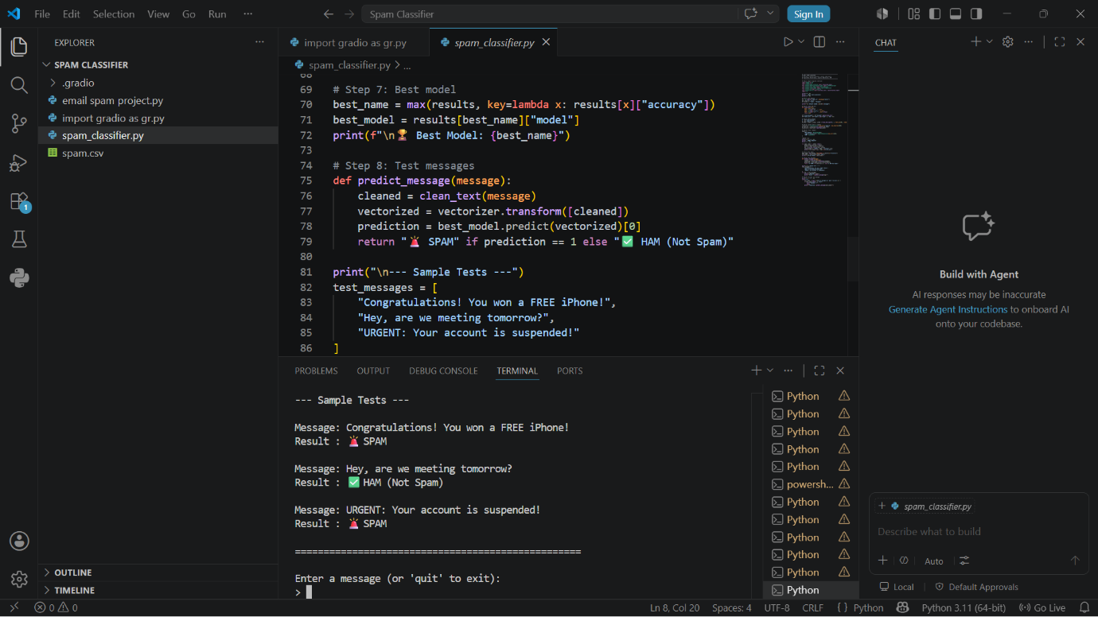

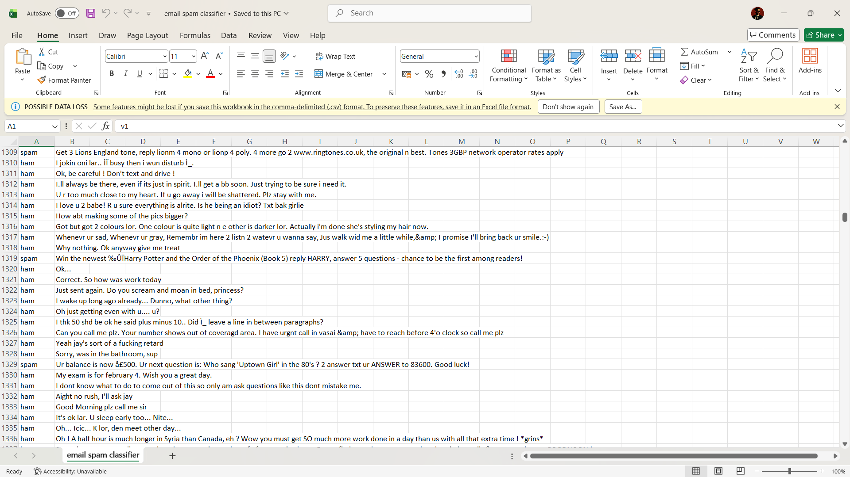
Output

Advantages:
1.Fast spam detection
2.High accuracy
3.Simple implementation
4.Useful for email filtering systems
5.Reduces unwanted messages

Limitations:
1.Accuracy depends on dataset quality
2.Cannot detect advanced phishing attacks
3.Requires training data

